Assignment: Exercise, Normalization
Karen Flores
University of San Diego

Assignment: Exercise, Normalization
Taking in consideration the following table:
Student (StudentNum, StudentName, NumCredits, AdvisorNum, AdvisorName, (CourseNum, CourseDescription, Term, Grade))
- Identifying repeating groups: CourseNum, CourseDescription, Term, Grade
- Normalizing
  - Student table to the first normal form:
Student (StudentNum, StudentName, NumCredits, AdvisorNum, AdvisorName)
StudentCourse(StudentNum, CourseNum, CourseDescription, Term, Grade)
  - Advisor to the first normal form:
Student (StudentNum, StudentName, NumCredits)
Advisor(AdvisorNum, AdvisorName)
- The data base have the following tables
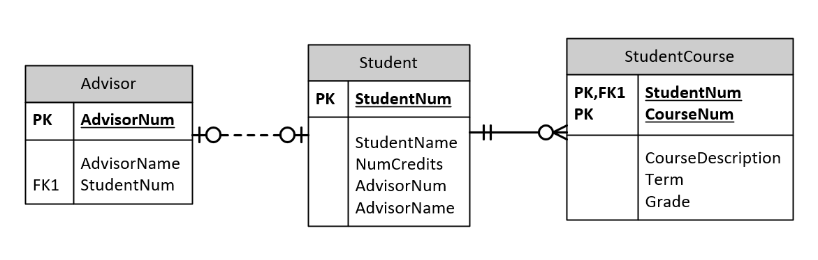
Figure 1. Normalized Student Table
Student (StudentNum, StudentName, NumCredits)
Advisor(AdvisorNum, AdvisorName)
StudentCourse(StudentNum, CourseNum, CourseDescription, Term, Grade)
- To allow the relation from students to Course be 1 to many, the next modifications need to be made:
  - Create a table Course
Course(CourseNum, CourseDescription)
  - Remove fields from Student Course table:
StudentCourse(StudentNum, CourseNum, Term, Grade)
  - This will be the final schema:
Student (StudentNum, StudentName, NumCredits)
Advisor(AdvisorNum, AdvisorName)
Course(CourseNum, CourseDescription)
StudentCourse(StudentNum, CourseNum, Term, Grade)

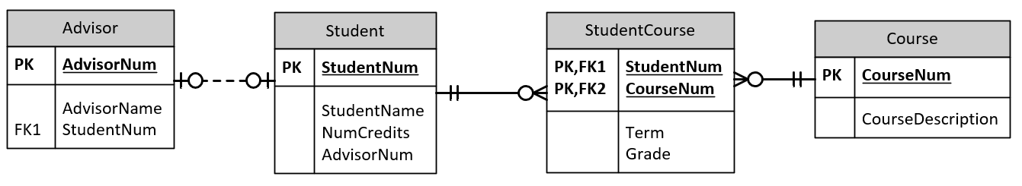
Figure 2. Normalized Data Base Design for College Data Base

