West Health Group: Strategic Planning Process Map
Karen Flores
University of San Diego

West Health Group: Strategic Planning Process Map
West Health is a nonprofit and nonpartisan group of organizations whose mission is to create strategies for lowering health care costs that impact the access of senior population to high quality health services; and, provide affordable health and support services that preserve and protect senior citizens dignity, quality of life and independence (West Health, 2109). West Health is composed by three nonprofit organizations: The Gary and Mary West Foundation, The Gary and Mary West Health Institute, and the Gary and Mary West Health Policy center (West Health, 2109). Currently, this organization creates and fosters new integrated data driven care model to improve outcomes and quality of life of senior populations and their families (West Health, 2109).

Step One: Set the State
The challenge ahead calls for the involvement of different Teams: Top Management, Data Science and Clinical Team. All of these groups have different set of characteristics and their roles will focus on their area of expertise throughout strategic plan development. Table 1. Definition of Teams involved in Strategic Plan according to their Role and Responsibility shows the members of the different teams by their role and the team responsibilities. Main stakeholders or decision makers can be identified as those roles that are in bold print and has a star marker. These actors will have the final decision within the scope of their team affiliation. The main objectives of each team are presented in the Figure 1. West Health Teams Main Scope.
The main objective of the Top Management Team will be to review that the strategic plan objectives align with the mission of West Health. The main stakeholder and decision maker is defined as the Chief Executive Office who will have the final decision over the strategic plan. The main objective for the Data Science Team will be to evaluate whether the strategic plan follows the best practices for data science project development in relation to health care organizations. If there is any controversy surrounding this topic, the final decision will rely on the Technical Director of Data Science. Clinical Team consists of representatives of Geriatric and Palliative Physicians, Emergency Medicine Physicians Research Associate and Case Management Support Professionals, Geriatric Nurses, and a patient representing the target population. The main objective of the team will be to review if the strategic plan align with current business processes. The main stakeholders and decision makers of this group will be identified as the representative of Geriatric and Palliative Physicians, Management Support Representative and Representative of Geriatric Nurses which will take a vote on any controversies.
On the other hand, the Facilitators Team will have as a main objective the successful building of a sense of ownership and facilitating correct communication within and between different teams (Ebener & Smith, 2015a). Our team has the experience with many communication tools that can be used within teams to facilitate the exchange of ideas. In addition, our experience with Agile Methodologies helps us to define SMART goals that at the end will be actionable and will have measurable results. For our group to be successful, all the teams must work taking in consideration the mandates enumerated on Table 2. West Health Mandates for Strategic Plan Development.
The proposed timeline for this project can be found in the following Figure 2. Project Timeline Definition for West Health Project. The timeline consists of four defined time frames with 4 weeks direction that has 4 main goals. Each of the goals will have different tasks that will be defined by the members of each team. All tasks should have SMART objectives and should be actionable. Each task will have an owner in charge of reviewing the progress.

Step Two: Environmental Analysis
Health care costs in the U.S. is complex problem that is related to many factors such as, regulatory, political (Hoffman, 2003; Silva, Farrell, Shandra, Viswanathan, & Schwamm, 2012), financial (Mays, Atherly, & Zaslavsky, 2017), and commercial (Brill, 2013). West Health Group was founded with the main purpose of becoming a health care provider that would provide high quality health care services, in addition, to promoting the reduction of health care costs (West Health, 2109). For this purpose, West Health Group has defined three main stakeholders with responsibilities support the provision of health care services and promote the decrease in costs. Figure 3. West Health Group of Stakeholders shows the relation between the main stakeholder and other stakeholders. As it is portrayed in the figure, there is a clear distinction between scopes which allow each team to focus on their internal objectives, and, at the same time, support the main objective. These separation of concerns will allow them to change in response to external changes without affecting the whole organization. In addition, this organization tackles research and regulatory areas which makes their approach comprehensive and sustainable.
Figure 4. SWOT Analysis of West Health Group contains a comprehensive list of Strengths, Opportunities, Weaknesses and Threats. The main strength of West Health group is their organization and division of concerns that enables the organization to constantly change without being disrupted. Other strengths rely on the expertise of their workforce and data collection. These strengths come in hand with the weaknesses of West Health Group. First, population aging may have an impact on the level of expertise. In addition, the use of information systems and the exchange of data with internal and external collaborators can put them at risk of cyberattacks and data breach. For the areas of opportunities for West Health Group, there a couple subjects that will benefit West Health Group, such as, changes in the regulation of costs in relation to health care provision. In addition, the lack or minimal regulation of telemedicine present a great area of opportunity. The increase in the baby boomer population can also present as a great opportunity to have more potential clients. Nevertheless, there are some threats to West Health Group, such as, difficulty on reimbursement processes, the limited influence that West Health Group has on training, impending global financial crises, and disruption of services by third parties.
West Health Group is an impressive organization that has a very comprehensive approach of how to work towards the solution on the complex issue of providing health care and decreasing costs. Nevertheless, aging population is an issue that will affect this organization in both ways. First, aging of the workforce will pose a risk of losing valuable know-how, technical and business rules in relation to health care workforce. Second, it will increase the number of potential users. In order to tackle this, West Health Group can implement models like the University of Texas Medical Branch (University of Texas Medical Branch, 2019) to create hacker models with the objective of creating new ideas and attracting new valuable talent to their workforce. This new model can set the first step towards the creation of proprietary technology that may decrease the dependency of West Health on third parties. Therefore, the creation of Hacker groups and, subsequent, creation of proprietary technology would be the recommended strategy for West Health Group. This strategy will help West Health Group to increase their reach, generate new ideas and detect potential talent. Overall, West Health group is giving a thoughtful sustainable answer to a very complex problem, such as, health care provision and health care costs.

Step Three: Describe the Culture
West Health Group (2109) website states the mission as: “Our mission is to lower healthcare costs to enable seniors to successfully age in place with access to high-quality, affordable health and support services that preserve and protect their dignity, quality of life and independence”. This mission statement allows us to understand about core values, philosophy, and beliefs of West Health Group. Additionally, it helps us to understand towards which direction West Health Group is aiming their strategic plan. As discussed by Ebener & Smith (2015), a mission statement has three components: (1) business, (2) purpose, and (3) values.
The business component of a mission statement refers to what product or services the organization provides to their customers (Ebener & Smith, 2015b). In the case of the West Health Group, the business is directly related to lowering health care costs (West Health, 2109). In addition, Ebener & Smith (2015) describe that a mission statement must include a purpose. The purpose has the goal of clarifying the social benefit that an organization intends to bring to the society (Ebener & Smith, 2015b). As it is stated on the mission of the West Health Group, the benefit that this organization intends to bring to the senior population will be successful aging.
Values are the third component of a mission statement. These values can express how an organization conducts itself, instrumental values, or what the results the organization expects, expressive values. The instrumental values for West Health Group are giving access in place to seniors to high quality and affordable services. The expressive values of West Health Group comprehends the preservation and protection of the dignity, quality of life and independence of senior population. In conclusion, West Health Group has a mission statement that includes all the three elements recommended by (Ebener & Smith, 2015b).

Step Four: Identifying Strategic Areas
There are two main areas of concern for West Health Group for support activities: structure (division) and strategic resources (human); and, for service delivery: research(pre-service). The division of West Health Group into three groups had allowed this organization to adapt rapidly to the changing external environment and reach their goals of promoting decrease of health care thus providing a support for all service delivery activities. On the other hand, Research has allowed West Health Group to create outcome based models that support their main goal of providing affordable high-quality health care in support or pre-service and after-service activities. Finally, the strategic resources have a big impact on point-of-service activities and any loss of expertise will impact these activities (clinical operations quality, process innovation, patient satisfaction), as well as, other pre-service activities (pricing, target market, promotion). Therefore, these activities need to be included into a strategy that reinforce strengths and leverage risks associated the them.
One of the mayor strengths of West Health Group is the separation of concerns of its different groups. This organizational capability enables this group to add new components to their organization without disrupting its main business activity. Therefore, a change in division to limit the scope of action of information technology may allow West Health Group to create a new set of capabilities. This change can be implemented in steps in order to allow more control on the structure change. Additionally, West Health Activities currently performs research activities and has demonstrated great expertise on the matter. This activity can be reinforced and standardized in order to allow West Health Group new technological and methodological capabilities. By standardizing the methodology, West Health Group can guarantee that its models can be implemented in external scenarios and increase expertise on its collaborators.

Step 5 and 6: Strategies and Action Steps
Strategic Area of Concern:
Loss of strategic human resources and expertise as a result of aging workforce
Strategy:
Attraction of new talent through the implementation of hackathon events.
Action Step 1: | Action Step 2: | Action Step 3:
Owner: Communications & Public Relations Manager | Owner: Communications & Public Relations Manager | Owner: Operations and Human Resources Manager
Definition and creation of a framework that will serve as base for hackathon events. | Identification of Partners and creation of a partner network for hackathon. | Implementation of Hackathon Events
Strategic Area of Concern:
Reinforcement of the research and development process for creating outcome based models that promote affordable high-quality health care delivery
Strategy:
Creation of a framework that will allow the creation of outcome based models that can be implemented by third parties.
Action Step 1: | Action Step 2: | Action Step 3:
Owner: Strategy & Succesful Aging Vicepresident | Owner: Chief Strategy Officer | Owner: Operations & Human Resources
Identification of successful outcome based models that resulted from hackathon events or other sources. | Model formalization, standardization and preparation for release and implementation of third party environment. | Implementation of models in third party environments (collaborators).
Strategic Area of Concern:
Reinforce the separation of concerns on West Health research group.
Strategy:
Creation of an organization in charge of information technology products and services related to health care delivery.
Action Step 1: | Action Step 2: | Action Step 3:
Owner: Chief Strategy Officer | Owner: Chief Strategy Officer | Owner: Operations and Human Resources
Identification of mission, vision, philosophy and values for Information Technology group. | Identification of Strategy Plan and Key Peformance Indicators for Information Technology Group. | Definition and implementation of organizational structure for Information Technology Group.

Step 7: Vision Statement
Vision Statement: To provide senior population high quality affordable health, support services, and technology that empowers, preserve and protect dignity, quality of life and independence.
West Health Group is an organization whose main goal is to lower health care costs to enable seniors to successful age (West Health, 2109). This organization has taken a different approach from traditional health care delivery models and it has focused its efforts on creation outcome based health care delivery methods through the use of different technical, technological, and methodological approaches. The different organizations that integrate West Health have helped to increase its influence over delivery models and costs of health care for senior populations. In order to have a more comprehensive approach towards delivery and due to changes in external factors, it is advisable for this group to become leader in technical, technological, and frameworks involved in health care delivery.
This vision forms part of a three step strategy whose main purpose is to reinforce, add and acknowledge the current technical and technological capabilities that West Health Group possesses. The vision can be implemented in a series of steps with a length of 2-3 years that involves: integration of groups that will generate new ideas and technologies; implementation of these technologies and their generalization among different environments; and, the release of these technical solutions or technologies as a product that can be consumed by third parties. This has the intention of adding a new capability to West Heath Care as a technology provider for health care delivery. At the end, West Health will have the capability of establishing itself as a leader in the creation of technological solutions that will aim at the reduction of costs and improving the quality of life of senior population, in addition to its current capabilities.

Step 8: Accountability
The strategy proposed for West Health Group has as its final goal the implementation of an Information Technology Group with the intention of increase the independence of West Health Group from technology provider. In order to have a successful implementation West Health must identify areas that will be benefitted by the use of technology and hackathon events. Participation in hackathon events and cooperation in the implementation of models that result from them are also fundamental tasks that will be necessary for this plan. These events will enable West Health Group to equip potential future workforce with the necessary knowledge to join their practice. Moreover, West Health must focus in the identification of models that that can be implemented by third parties.
The strategy has been divided into three milestones that can be reviewed on Figure 5. Timeline for Milestones Implementation for Strategic Plan. Each milestone has the intention of reinforcing and creation a new set of capabilities that will serve as a base for the next milestone. Each milestone has an estimated duration of one fiscal year and the first two actions are estimated to be implemented on a quarter (3 months). This figure also includes a relation of action and owner and this can also be reviewed on Step 5 and 6: Strategies and Action Steps. The owner of each task will facilitate the execution of the task and will be accountable for the results. Owners can delegate tasks, nevertheless, the outcome is responsibility of each identified task owner. Table 3. Relation of Strategic Areas of Concern with Owners and Results of Action Steps allow to review the expected outcome of each action step.
In order to consider that a task has been successful, owner must have to present the item or items described on Table 3. Relation of Strategic Areas of Concern with Owners and Results of Action Steps. Lack of delivery of results must be reviewed by owner and management leadership team in order to determine whether the timeline of the task needs adjustment, the task needs to be modified or is no longer needed. It would be necessary for managers and task owners to provide a relation of needed resources and allocation time for the tasks. Documentation around each decision must be provided along with current results and, in case of need, a definition for result for the task. If owner present a result meeting the criteria established on Table 3, next action step can be started.
At the end of each milestone, West Health Group stakeholders must review if the expected results had been delivered and if they are prepared to move to the following milestone. In case West Health Group determines that the expected results have not being delivered. The facilitators will review the current status and, with assistance of West Health Group, will determine if the timeline needs to be adjusted, additional actions need to be implemented, or if further actions are not needed. Each step must require that action owners allocate time on their schedule and allow other collaborators to allocate time for this process. Success of a milestone will be determined as the initiation of a new step.
For the success of the implementation of the strategy plan it is necessary to provide a specific communication channel that will be used to communicate about the progress of the strategic plan implementation, risks and concerns. To set a culture of blame free cooperation and be open to hear constructive feedback from peers and external agents. West Health must be able to provide some access to some resources that can be used during the course of the hackathon events, such as: access to some data, access to installations, or share knowledge. For steps, such as implementation of models, West Health must have a tight communication and involvement during the process. During the last milestone, to promote participation, West Health must provide communication channels that involve all the parties involved or affected by this change.

References
Brill, S. (2013). Bitter Pill : Why Medical Bills Are Killing Us. TIME, 1–28. Retrieved from https://time.com/198/bitter-pill-why-medical-bills-are-killing-us/
Ebener, D. R., & Smith, F. L. (2015a). Step One: Set the Stage. In Strategic Planning: An Interactive Process for Leaders (pp. 9–22). Mahwah, New Jersey: Paulist Press.
Ebener, D. R., & Smith, F. L. (2015b). Step Three: Describe Your Culture Articulate the Mission,Vission and Core Values. In Strategic Planning: An Interactive Process for Leaders (pp. 37–50). Mahwah, New Jersey: Paulist Press.
Hoffman, B. (2003). Health care reform and social movements in the United States. American Journal of Public Health, 93(1), 75–85. https://doi.org/10.2105/AJPH.98.Supplement_1.S69
Mays, G. P., Atherly, A. J., & Zaslavsky, A. M. (2017). The Economics of Public Health: Missing Pieces to the Puzzle of Health System Reform. Health Services Research, 52, 2275–2284. https://doi.org/10.1111/1475-6773.12782
Silva, G. S., Farrell, S., Shandra, E., Viswanathan, A., & Schwamm, L. H. (2012). The status of telestroke in the united states: A survey of currently active stroke telemedicine programs. Stroke, 43(8), 2078–2085. https://doi.org/10.1161/STROKEAHA.111.645861
University of Texas Medical Branch. (2019). Maker Health Space. Retrieved from https://www.utmb.edu/maker
West Health. (2109). West Health. Retrieved from https://www.westhealth.org

Tables
Table 1. Definition of Teams involved in Strategic Plan according to their Role and Responsibility
Team | Members by Role | Responsibilities
Top Management Team | Chief Executive Officer *  Chief Strategy Officer  Chief Medical Officer  Vice President Strategy and Successful Aging  Vice President of Finances  Vice President of Communications and Human Relations  Vice President of Operations and Human Resources | - Scope Definition  - Review that all objectives align with mission and vision of West Health  - Review that project aligns with the values of West Health  - Reviews operability and sustainability of the project  - Write strategic plan with leaders from other teams
Data Science Team | Information Privacy Officer  Technical Director of Data Science *  Principal Investigator  Data Science/Software Engineer  Public Policy Researcher  Data Science Administrator | - Review that data information management complies with regulations  - Review that project design complies with best practices  - Review architecture of solution  - Definition of epics  - Estimation of Timelines  - Estimate Timelines of implementation with Clinical Team  - Estimate Timelines of testing with Clinical team  - Estimate iteration length for modification on new implementations with Clinical Team  - *Leader: Write strategic plan with leaders from other teams
Clinical Team | Representative of Geriatric and Palliative Physicians *  Representative of Emergency Medicine Physicians  Research Associate and Case Management Support Representative *  Representative of Geriatric Nurses *  Representative of Sample of Target Population (Residents ≥ 65 years old) | - Evaluate that objectives align with business processes  - Evaluate feasibility of implementation  - Evaluate User Experience and Usability  - Estimate Timelines of implementation with Data Science Team  - Estimate Timelines of testing with Data Science team  - Estimate iteration length for modification on new implementations with Data Science Team  - Leaders: Write strategic plan with leaders from other teams
Facilitators Team | Scrum Master | - Create a positive environment  - Structure strategic planning process  - Facilitate the group interaction  - Keep the group focused  - Encourage the group to think strategically  - Stimulate difference of opinions  - Move the process forward in a positive direction

Table 2. West Health Mandates for Strategic Plan Development
West Health Mandates
- Do not do harm
- Lower costs of health care for senior population
- Enable senior populations to access high-quality and affordable health care support
- Preserve dignity of patients
- Promote quality of life of patients
- Follow federal and local government guidelines and laws
- Comply with data security recommendations

Table 3. Relation of Strategic Areas of Concern with Owners and Results of Action Steps
Strategic Area of Concern:
Loss of strategic human resources and expertise as a result of aging workforce
Action Step 1: | Action Step 2: | Action Step 3:
Owner: Communications & Public Relations Manager | Owner: Communications & Public Relations Manager | Owner: Operations and Human Resources Manager
Result: Document that describes policies, regulations and procedures for a hackathon implementation | Result: Partnership with one or more organizations willing to participate on hackathon events | Result: Hackathon events implementation and new of outcome based models
Strategic Area of Concern:
Reinforcement of the research and development process for creating outcome based models that promote affordable high-quality health care delivery
Action Step 1: | Action Step 2: | Action Step 3:
Owner: Strategy & Succesful Aging Vicepresident | Owner: Chief Strategy Officer | Owner: Operations & Human Resources
Result: One or more outcome based models that can potentially be implemented in other environments | Result: One or more outcome based model ready for environment agnostic implementation | Result: Successful run of outcome based model
Strategic Area of Concern:
Reinforce the separation of concerns on West Health research group.
Action Step 1: | Action Step 2: | Action Step 3:
Owner: Chief Strategy Officer | Owner: Chief Strategy Officer | Owner: Operations and Human Resources
Result:  5 year strategic plan for Information Technology Group. | Result:  5 Key Performance Indicators for Information Technology Group | Result:  Information Technology Group startup

Figures
Figure 1. West Health Teams Main Scope
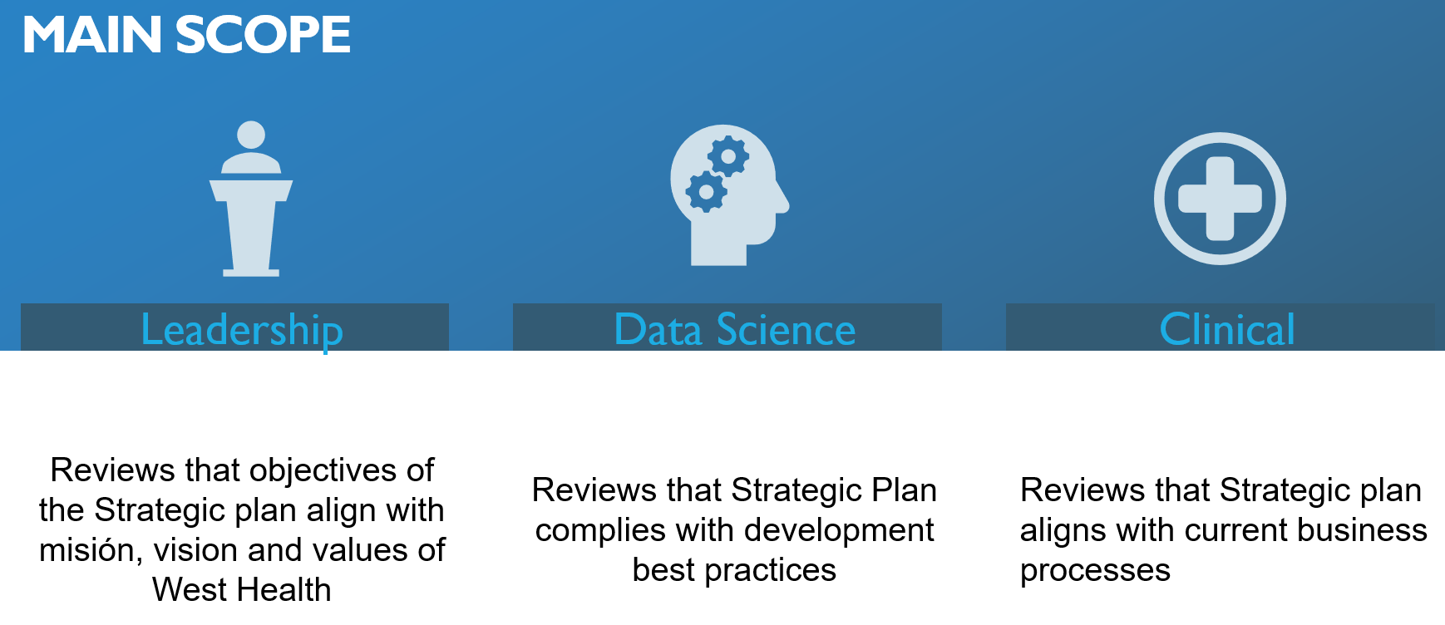

Figure 2. Project Timeline Definition for West Health Project
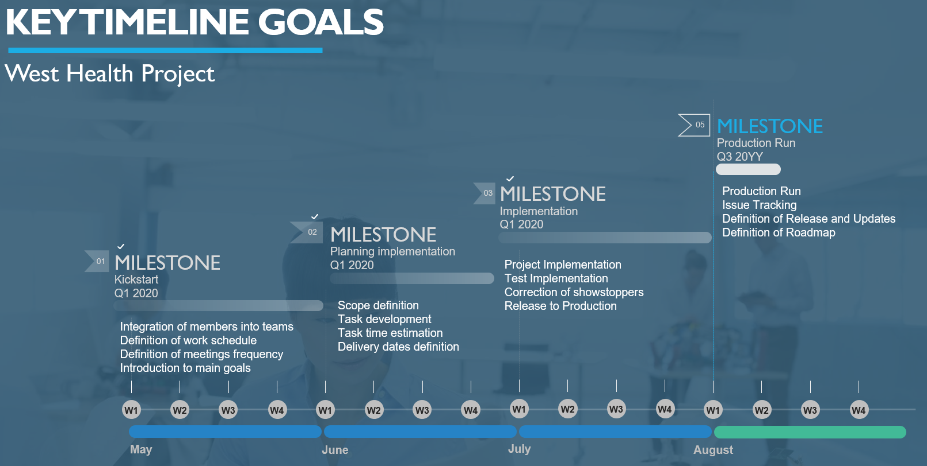

Figure 3. West Health Group of Stakeholders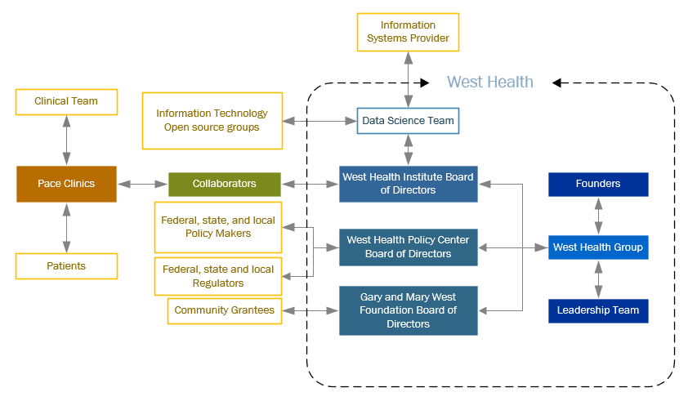

Figure 4. SWOT Analysis of West Health Group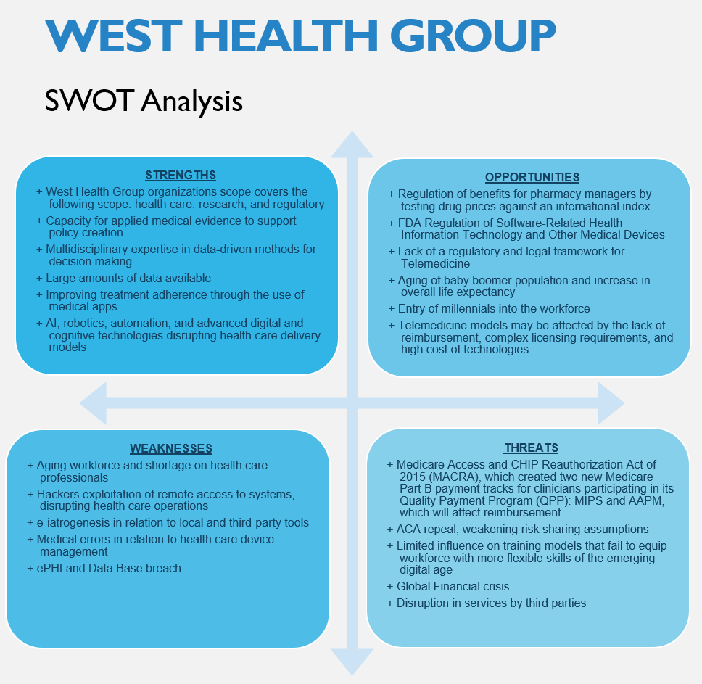
This figure include the detailed items in relation to SWOT. Items are grouped in the following categories: Strengths (Upper left quadrant), Opportunities (Upper right quadrant), Weaknesses (Lower left quadrant), and Threats (Lower right quadrant).

Figure 5. Timeline for Milestones Implementation for Strategic Plan