Home Visiting Service and Framework:
Strategic Business Proposal
Karen Flores
University of San Diego

Executive Summary
During early years, U.S. medicine was limited to longstanding relationship between patient and physician and remained changed until the appearance of the first insurance (Young & Kroth, 2018) which was later promoted by the government (Young & Kroth, Public health and the role of government in health care, 2018). In the early 20th century, acute care hospital became the central unit of healthcare which emphasized acute care mostly which gave rise to the health care paradox (Young & Kroth, Public health and the role of government in health care, 2018). This paradox has increased the pressure on Investor owned and non-profit health care organizations to do more with less resources (Turner, Broom, Elliott, & Lee, 2015).
In United States this paradox can be related to incidence of infant mortality in the U.S. Currently, the U.S. ranks amongst the 27th place amongst industrialized nations for infant mortality with higher incidence on southern states (Hirai et al., 2014). This issue increase the need to implement simple data-driven strategies in order to decrease the incidence of low-birth weight, infant mortality and other risk factors. Home visiting service provides an efficient data-driven strategy for implementing interventions to leverage these issues. This service is part of the platform Home Visiting Service and Framework which consists of 5 elements: home visiting service, mobile application, cloud data storage, desktop application, and practice guidelines. The most important goal of this platform is to avoid waste resource and continuous result tracking for health care organization like Heartland Health.
The analysis of Heartland Health has given some insight on the costs and revenues over the past 3 years. Heartland Health Costs are divided into four categories: providers, technology, supplies, and indirects. Most of the resource consumption for Heartland Health is related to the time providers followed by indirects, technology and supplies. The analysis of variance over one-month expense budget shows a positive variance on providers and indirects; and a negative variance related to technology and supplies. Further analysis will be needed to determine the exact causes for these increased cost of technology and supplies. Nevertheless, these points towards an increase resources in relation to diagnostic procedures or clinical examination that varies between the two locations.
Heartland Health is a respected and well-known local health care organization constituted of 12 team members, led by one physician leader. The Home Visiting Service and Framework is a platform that will provide mobile tools to support the provision of home visiting services for pregnant women by Community Health Workers (CHW). The proposed solution will integrate various components that can affect the workflow of Clinical Services and Health Informatics teams and the assumption is that clinical services and health informatics teams will be involved in the evaluation of different aspects of the platform. In addition, it is assumed that both team will review costs, technical and technological requirements.
Home Visiting Service and Framework is a platform that uses data-driven strategies to decrease the incidence of low-birth weight and infant mortality, confirm the intervention on a risk factor, avoid resource waste (Schieve et al., 2016). Interventions, such as home visiting services assist in the identification and intervention on risk factors with low-cost interventions. Furthermore, the data generated on these interventions can be synchronized on demand or continuously to a cloud through the platform to a data repository that will allow continuous analysis of the results. As a result, Home Visiting Service and Framework is a platform that can assist to implement and measure the impact of interventions on infant mortality continuously.

Home Visiting Service and Framework:
Strategic Business Proposal
Throughout the history, there has been multiple factors involved in the evolution of U.S. health care system. During early years, U.S. medicine was limited to longstanding relationship between patient and physician, which involved a fee-for-service agreement (Young & Kroth, 2018). For years, this relationship was not changed until the appearance of the first insurance against-sickness through a third party (Young & Kroth, 2018). The creation of the Blue Cross hospital insurance can be considered as a pivotal factor during early beginnings of the U.S. health care system (Young & Kroth, Public health and the role of government in health care, 2018). This model was replicated in subsequent years by hospitals and had a more prominent use after World War II due to the tax exempt status provided by the government (Young & Kroth, Public health and the role of government in health care, 2018). This can be accounted as the first milestone for federal contribution into the promotion of health insurance coverage.
One of the first provisions for the Social Security legislation and public health care was created by Franklin D. Roosevelt in 1933. This provision included publicly funded health care programs (Manchikanti, Helm Ii, Benyamin, & Hirsch, 2017). In 1965, President Lyndon B. Johnson signed one of the most significant legislations for health coverage: Medicare and Medicaid (Manchikanti et al., 2017). This government-sponsored insurance aimed to cover older adults and low-income populations (Young & Kroth, Benchmark Developments in U.S. Health Care, 2018). As a result, the role of the government during the promotion of coverage has been a determinant factor on the creation of programs such as Medicaid, Medicare, and, more recently, Affordable Care Act (ACA) (Manchikanti et al., 2017).
In the early 20th century, acute care hospital was becoming the central unit of healthcare. The emphasis was made on providing care for acute patients and mostly neglecting outpatient, ambulatory, critical care and rehabilitation (Young & Kroth, Public health and the role of government in health care, 2018). All these factors contributed and continue to contribute to the current status of the U.S. health care system paradox: great spending and low health care quality. As a result of this, on 2010, the Affordable Care Act was created in order to leverage some of the issues of the U.S. health care system.
Currently, health care organizations derive their flow of funds from two main categories: patients and non-patients (Cleverley, 2018). On the other hand, the main suppliers for health care organizations can be categorized into the following groups: employees, equipment suppliers, service contractors, vendors of consumable supplies and lenders (Cleverley, 2018). More than 50% of the funding for a hospital derives from public funding, such as, Medicare and Medicaid. And, private insurance makes the second largest contribution to hospital funding (Cleverley, 2018). Over the past years, health care organizations have developed several different contractual relationships with payers that derive from different modes of payment units (Cleverley, 2018) and with added capitalization problems (Vega et al., 2016).
Whether health care organizations are investor owned or non-for-profit, there is an increasing pressure to do more with less resources (Turner, Broom, Elliott, & Lee, 2015). This can be challenging for large institutions where efficiency of facilities drops as the size of the facility gets larger (Turner et al., 2015). This lack of efficiency was reflected in the United States low rank in overall health care performance for developed countries (Deloitte, 2019). Nevertheless, global health care spending is projected to grow 5.4% over the next 3 years (Deloitte, 2019).

Product Description
United States ranks amongst the 27th place amongst industrialized nations for infant mortality with higher incidence on southern states (Hirai et al., 2014). Moreover, infant mortality is one indicator that evidences disparities in race, socio-economic status and geography (Hirai et al., 2014). Therefore, infant mortality rate has been acknowledged as a reliable indicator for the characterization of health status of a community (United States-Mexico Border Health Commission, 2015) and has been identified a sentinel metric (Hirai et al., 2014; Redding et al., 2015). It has been found that infant mortality is closely related to low birth weight on all ethnicities (Kominiarek & Peaceman, 2017; Park et al., 2019). And, on the case of surviving infants, low birth weight have been linked to higher incidence of developmental disabilities (Schieve et al., 2016).
Hirai et al. (2014) highlight the importance of implementing data-driven strategies that will reduce the incidence of low-birth weight and infant mortality. Strategies can be as simple and impactful as the recommendation for supine sleep issued by the American Academy of Pediatrics (Hegyi, Teitler, Reichman, Ostfeld, & Schwartz-Soicher, 2017). Moreover, these strategies should be directed at decreasing leading risk factors (Hegyi et al., 2017) and inadequate gestational weight gain (Kominiarek & Peaceman, 2017). One strategy for preventing low birth weight is home visiting service. This strategy main goal is the provision of evidence-based services and a support network (Kominiarek & Peaceman, 2017; Redding et al., 2015). In addition, this strategy has proven its efficacy at lowering the incidence of lower birth weight infants and infant mortality (Redding et al., 2015).
In order to allow health care providers to implement a practical approach at reducing infant mortality through a home visiting service, Home Visiting Service and Framework provides a complete platform on which health care providers can implement a data-driven approach supported by software and hardware infrastructure. Figure 1 depicts the elements that integrate this platform, which consists of 5 elements: Home Visiting Service, mobile application, cloud data storage, desktop application, and practice guidelines. Home Visiting Service is a service that aims to allow health care providers to approach vulnerable populations and provide evidence based recommendations. The most important feature of this service is that it avoids waste resource by identifying and targeting geographic areas that will be greatly benefited by this program. The primary intention of this service is to provide support services to pregnant women through motivational interviewing, counselling, and goal setting.
Interactions with pregnant women will generate data every time and this data will be acquired through a simple form on a mobile application. This application will allow to securely store and upload data to a cloud data storage. The cloud data storage will be able to store data securely and further making it available for other applications to use. The desktop application will be able to review stored data and summarize data from patients in easy to read dashboards. Furthermore, this desktop application will be able to serve as basic Electronic Medical Record. At the end, health care organization will be able to assess the effectiveness of the home visiting service through the review of key performance indicators.
Home Visiting Service and Framework is a cloud based product that can be accessed through any mobile device in a secure manner due to the fact that uses two-factor authentication. The advantages over other frameworks is that this platform integrates a mobile application that helps distribute data in a secure and timely manner. Moreover, this platform requires little or no investment on hardware and maintenance due to the fact that it is a cloud based platform. Please, refer to the Information about Competitive Analysis on: Table 1.

Organizational Analysis
Heartland Health Costs are divided into four categories: providers, technology, supplies, and indirects. The calculated Relative Value Units (RVUs) for these categories help to understand the resource consumption on them. Most of the resource consumption for Heartland Health is related to the time providers spent on a 15 minute visit. Following the time of the providers, the second most used resource are related to indirects which include personnel (information technologist, biller, receptionists, and medical assistants) and recurrent costs such as, utilities and lease. In third place comes the resource use of technology materials such as, EKG machines, copiers, computers, ultrasound machine, and electronic scales. Finally, the category corresponding to supplies comes at last with the least resource consumption of these categories. These resources are divided between two offices: Heartland South and Heartland South.
A 15-minute medical visit costs in Heartland Health are related also to the categories mentioned above. The category which represents a larger expense is related to the indirects that are related to the medical visit. These indirects costs account for $12.79 US DLLS for each 15-minute medical visit. Following indirects, providers account for $24.65 dollars per 15 minute medical visit. Next to these categories, technology and supplies account for $1.18 and $0.89 US DLLS. In other words, the category that consumes more resources are the indirects and the category that consumes less resources are the supplies. As a conclusion, indirects are generating more expense during a 15-minute visit to Heartland Health.
The analysis of variance over one-month expense budget shows that all categories have a variance between a planned budget and actual budget. The positive variance on the time of the providers and indirects is a reflect of less resource consumption on these categories. On the other hand, the negative variance related to technology and supplies reflects more resource utilization of these categories. Furthermore, On the One-Month Productivity Report, there is a negative variance in both Heartland Offices, yet, Heartland South has a higher negative variance than Heartland North. The overall variance of the categories yields a positive variance, nevertheless, an increase in negative variance in the following months can yield a negative variance over a long term.
Upon the analysis of the Heartland Health One-Month Expense Budget and the Heartland Health One-Month Productivity Report, there is a negative variance on the two offices that is a reflection of the negative variance of technology and supplies. These negative variance shows that there is an increase in the expense or resource consumption related to the technology and supplies. Further analysis will be needed to determine the exact causes for these increased consumption. Nevertheless, these can be indicative of an increase in the use of technology resources and supplies in relation to diagnostic procedures or clinical examination. Moreover, the greater negative variance on Heartland Health One-Month Productivity Report lead us to think that increased resource utilization is associated to this office. Since the variance Heartland North is minimal, it seems that resource utilization is better managed on this office. Therefore, I would recommend that Heartland South follows the best practices or procedures implemented by Heartland North in order to decrease expenses.

Management Overview
Heartland Health is an organization constituted of 12 team members, led by one physician leader. This organization is divided into two different locations that supervised by a local team leader. Figure 3. Heartland Health Leadership Organization Chart, shows the distribution of team members between the two locations, the members of functional teams and their supervisor. This organization incorporates three functional teams: front office, clinical services and health informatics. The division of teams is portrayed in Figure 2. Heartland Health Main Organization Chart, there is an illustration of the three teams:
The Home Visiting Service and Framework is a platform that will provide mobile tools to support the provision of face-to-face services for pregnant women by Community Health Workers (CHW). With the assistance of the tools, CHW will be responsible of guaranteeing the connection between pregnant woman and health services, motivational interviewing, counselling, and goal setting. Therefore, CHW must have a post-secondary education or bachelor degree, fluency on the language of the community, and, preferably, being a member of the target community (Olaniran, Smith, Unkels, Bar-Zeev, & van den Broek, 2017; Redding et al., 2015; WHO, 2007). Compensation for CHW can based upon the mean annual wage published by (U.S. Bureau of Labor Statistics, 2012) which is ~$43,480 U.S. dollars per year.
The proposed solution will integrate various components that can affect the workflow of Clinical Services and Health Informatics teams, for more information review Figure 2. Heartland Health Main Organization Chart. The assumption is that Clinical Services team will evaluate the impact on clinical workflow, potential risks on the use of the framework, implementation plan, and the need for the incorporation of new personnel. On the other hand, Health Informatics team will most likely evaluate data security of the application, technical implementation, and technology requirements. Finally, it is assumed that both teams will evaluate startup, operational and maintenance costs.
Refer to Figure 4. Heartland Health Proposed Strategic Plan to review the complete plan. The proposed strategic plan for Heartland Health is directed towards transforming this health care organization into the main health care provider pregnant women. The main goal of this strategic plan is to decrease the infant-mortality rate, nevertheless, two more goals were added in order to provide a mark-up for the implementation of the Home Visiting Service and Framework. Objectives take in account key performance indicators: infant mortality rate; direct costs related to low gestational weight; and, implementation of data-based solutions. Finally, the action plan delimits the scope for the Home Visiting Service and Framework.
The analysis of the Strengths, Weakness, Opportunities and Threats (SWOT) Analysis is a methodology that helps to understand the current status of Heartland Health in relation to internal and external factors. Figure 5. Heartland Health SWOT Analysis shows the identified strengths, weakness, opportunities and threats for Heartland Health. The identified strengths for this organization are in deep relation with the knowledge, commitment and close-relation with the community. Of the identified areas of opportunity, Heartland Health is an organization that can broaden the scope of population and incomes resources by reaching out to the growing population. The identified weaknesses are related to the lack of interaction of Heartland Health with outside sources, namely: ideologies and technology practices. Finally, the external threats that can affect this organization are mostly related to the changes that will be initiated by the construction of an HMO clinic, new industries, lack of relation with health insurance providers, no possibility of providing meaningful use attestation, and population mobility.

Financial Prospectus

Revenue and Expense Assumptions
1. Sales/Revenue—First year’s annual volume increase is 100 RVUs per month x 12 months = 1200 RVU/yr. Revenue is RVU= $45. 1200 x $45 = $54,000. Second and third year annual increases in patient visits of 80 visits a month= 960 RVU/yr. x $45 = $43,200. Similar electronic medical record implementations experienced an increase in the volume of patient office visits/revenue due to ability to send automatic text messages reminders of visits and seasonal reminders of flu shots (Agency for Healthcare Research and Quality, 2016).
2. Expense—sum of lines 5-9
3. Operating income—sales/revenue minus cost/expense
4. Operating margin—divide operating income by revenue x 100 to obtain percent

Expense Assumptions
5. Salaries and wages--Training and productivity loss; 4 providers 40 hours training each x $200/hr. = $32000. 6 receptionists/medical assistants 40 hours training x $15 = $3600. 1 biller 40 hours training x $15 = $600. $32000+$3600 +$600=$36,200 Informatics technician training required—No additional.
6. Materials and supplies required—no additional
7. Technology—contract services annually--support for computerized technology is $8000
8. Depreciation and Amortization—none {use when recording the depreciation of an asset [e.g. land, building or equipment (computer)] reducing their historical cost by accumulated depreciation (refer to page 264 in textbook for more details) Amortization schedule records the principal and interest contained in each payment.}
9. Interest—none (use when loan is involved and cost of interest must be considered)
10. Total expense— sum of lines 5-9

Net Income Assumptions
11. Net Income—sales/revenue minus the total expense

Cash Flow Report Assumptions
12. Net income—repeat net income from line 11
13. Depreciation—repeat line 8
14. Borrowing—repeat line 9
15. Total sources—add lines 12-14
16. Capital purchasing—software $9,000 for cash purchase; no building; no equipment
17. Working capital—none
18. Total Uses—add lines 16 and 17
19. Cash at Beginning of Period—none
20. Net Cash activities—total sources minus total uses
21. Cash at Ending of Period—add line 19 and line 20

Volume/Productivity Report Assumptions
22. Volume statistic—RVU = 15 minutes of office time with provider; the volume indicator relates to the sales/revenue: Year 1: 1200, Year 2: 960, and Year 3: 960
23. Cost per unit—total expense divided by RVU
Please, refer to: Table 2. Heartland Health: Electronic Medical Record 3-Year Financial Prospectus

Financial Summary
The health information technology project proposal is for the implementation of an electronic medical record in the offices of Heartland Health (Table 1). In the first year, RVUs are forecast to increase by 1200 with an additional revenue of $54,000.00. The first year’s operating expense of for the EMR installation is $44,200.00. The operating margin is 18% for the first year. The cost per unit for Year 1 is $36.83. A capital cash purchase of $9,000.00 is required. Cash at ending of a 3-year period is $71,200.00.

Marketing Strategy
Home Visiting Service and Framework is a platform that uses data-driven strategies to decrease the incidence of low-birth weight and infant mortality. This platform will allow to confirm the intervention on a risk factor, avoid resource waste and proper referral to tertiary perinatal centers related to the attention of low-birth weight and infant mortality. High risk and low risks pregnancies will be identified and referred to the correct levels of care. This can help to decrease the burden and stress to health care providers within the organization; decrease costs to health care organization and population; decrease risks; and, strengthen the ties between the community and the health care organization .
Home Visiting Service and Framework platform have two main features: Home Visiting Service and Practice Guidelines. For the Home Visiting Services, the champions will be the community health workers (CHW). On the other hand, Practice Guidelines features will have as their champions the Leadership team of the health care organization. CHW are trained individuals that can create a liaison between health care organizations and the community (Olaniran et al., 2017) and assist to decrease significantly neonatal mortality in communities with limited access to health care facilities (Behrman, Butler, & Editors, 2007; Gogia & Sachdev, 2016). On the other hand, the evidence-based recommendations will be developed and championed by the Leadership team of the health care organization. As a result, we will have recommendations that will be evidence-based and designed taking in consideration the expertise on the community of the health care organization.
In the United States, the cost medical care of preterm births is around $16.9 billion dollars and $1.9 billion dollars for maternal delivery (Behrman et al., 2007)with life-long sequelae (Schieve et al., 2016). Interventions, such as home visiting services assist in the identification and intervention on risk factors with low-cost interventions, such as: motivational interviewing, counseling and goal setting. The data generated on these interventions can be synchronized on demand or continuously to a cloud repository for continuous analysis and results display. As a result, Home Visiting Service and Framework is a platform that can assist to implement and measure the impact of interventions on infant mortality continuously.
Home Visiting Service and Framework is a platform that will be constantly monitored for usage and errors. This monitoring will serve as a tool for continuous improvement of the platform and detect new possible use case scenarios. In addition, there will be a continuous cycle for feedback retrieval from stakeholders, such as, Clinical Services and Community Health Workers. The source of the feedback will include a report an issue section in all the applications, an available mail account, and a chat bot service. All of the issues will be collected and discussed with the development team in order to assign feasibility and inclusion on the roadmap.
Home Visiting Service and Framework platform will take in account two types of key performance indicators: clinical and technical. Clinical key performance indicators will help to measure, review and assess the interventions performed to reduce risks related to infant mortality rate. The key performance indicators considered at this stage are: all neonatal deaths and neonatal deaths on patients that received intervention. Secondary performance indicators will include: perinatal mortality rate; cause specific mortality including deaths due to maternal sepsis, tetanus, asphyxia and prematurity; and, direct costs related to low gestational weight. On the other hand, technical performance indicators will collect telemetry data from the platform usage and detected errors. These data will be collected with the purpose of understanding the patterns of usage of the platform, billing, error correction, error prevention, and error prediction.

References
Behrman, R. E., Butler, A. S., & Editors. (2007). Prematurity at birth: Determinants, consequences, and geographic variation. Preterm birth: causes, consequences and prevention. https://doi.org/10.1080/01443610802243047
Bowles, M., & Pty, F. (2009). Implementing successful transformational leadership competency development in healthcare. Futures.
Cleverley, W. O. (2018). Financial Environment of Health Care Organizations. In Essentials of Health Care Finance (5th ed., pp. 31–56). Burlington, MA: Jones & Bartlett Learning.
Deloitte. (2019). 2019 Global Health Care outlook: Shaping the Future, 41. Retrieved from https://www2.deloitte.com/content/dam/Deloitte/global/Documents/Life-Sciences-Health-Care/gx-lshc-2016-health-care-outlook.pdf%5Cnhttp://www.deloitte.com/healthcareoutlook.
Gogia, S., & Sachdev, H. P. S. (2016). Home-based neonatal care by community health workers for preventing mortality in neonates in low- and middle-income countries: A systematic review. Journal of Perinatology, 36(S1), S54–S72. https://doi.org/10.1038/jp.2016.33
Hegyi, T., Teitler, J. O., Reichman, N. E., Ostfeld, B. M., & Schwartz-Soicher, O. (2017). Prematurity and Sudden Unexpected Infant Deaths in the United States. Pediatrics, 140(1), e20163334. https://doi.org/10.1542/peds.2016-3334
Hirai, A. H., Sappenfield, W. M., Kogan, M. D., Barfield, W. D., Goodman, D. A., Ghandour, R. M., & Lu, M. C. (2014). Contributors to excess infant mortality in the U.S. South. American Journal of Preventive Medicine, 46(3), 219–227. https://doi.org/10.1016/j.amepre.2013.12.006
Kominiarek, M. A., & Peaceman, A. M. (2017). Gestational weight gain. American Journal of Obstetrics and Gynecology, 217(6), 642–651. https://doi.org/10.1016/j.ajog.2017.05.040
Manchikanti, L., Helm Ii, S., Benyamin, R. M., & Hirsch, J. A. (2017). Evolution of US Health Care Reform. Pain Physician, 20(3), 107–110. Retrieved from http://www.ncbi.nlm.nih.gov/pubmed/28339426
Olaniran, A., Smith, H., Unkels, R., Bar-Zeev, S., & van den Broek, N. (2017). Who is a community health worker? - A systematic review of definitions. Global Health Action, 10(1). https://doi.org/10.1080/16549716.2017.1272223
Park, M. S., Sriram, S., Park, C.-G., Lee, K.-S., Kim, D.-H., & Jeon, J. (2019). Optimal birth weight and term mortality risk differ among different ethnic groups in the U.S. Scientific Reports, 9(1), 1–5. https://doi.org/10.1038/s41598-019-38583-x
Redding, S., Conrey, E., Porter, K., Paulson, J., Hughes, K., & Redding, M. (2015). Pathways Community Care Coordination in Low Birth Weight Prevention. Maternal and Child Health Journal, 19(3), 643–650. https://doi.org/10.1007/s10995-014-1554-4
Schieve, L. A., Tian, L. H., Rankin, K., Kogan, M. D., Yeargin-Allsopp, M., Visser, S., & Rosenberg, D. (2016). Population impact of preterm birth and low birth weight on developmental disabilities in US children. Annals of Epidemiology, 26(4), 267–274. https://doi.org/10.1016/j.annepidem.2016.02.012
Turner, J., Broom, K., Elliott, M., & Lee, J.-F. (2015). A Decomposition of Hospital Profitability. Health Services Research and Managerial Epidemiology, 2, 233339281559039. https://doi.org/10.1177/2333392815590397
U.S. Bureau of Labor Statistics. (2012). U . S . Bureau of Labor Statistics Occupational Employment Statistics Occupational Employment and Wages , May 2012 39-9011 Childcare Workers. Retrieved from https://www.bls.gov/oes/current/oes211094.htm
United States-Mexico Border Health Commission. (2015). Healthy border 2020: A. Retrieved from www.borderhealth.org
Vega, A. D., Meola, P. P., Barcelo, R. J., Ruiz, H. M. P., Oh, S. A., & Oh, T. (2016). Commentary on Current Trends in Rising Drug Costs and Reimbursement Below Cost. Managed Care (Langhorne, Pa.), 25(4), 41–49. Retrieved from http://www.ncbi.nlm.nih.gov/pubmed/27265971
WHO. (2007). Community health workers : Policy brief, (January).
Young, K., & Kroth, P. (2018). Benchmark Developments in U.S. Health Care. In K. Young, & P. Kroth, Sultz & Young's Health Care USA (pp. 23-44). Burlington, MA, USA: Jones & Bartlett Learning.
Young, K., & Kroth, P. (2018). Public health and the role of government in health care. In K. Young, & P. Kroth, Sultz & Young's Health care USA (pp. 301-47). Burlington: Jones & Bartlett Learning.

Tables
Table 1. Competitive Analysis of Home Visiting Service
Competitive Analysis
Buying Criteria | My Company | Community Health Access Project (CHAP) | Michigan Pathways to Better Health | Solution implementation
Functionality | HIGH | LOW | LOW | Framework implementation will be accompanied by a software application that will allow data input and data review.
Measurable outcomes | HIGH | LOW | HIGH | Every intervention through application will generate data for later use.
Profitability | HIGH | MID | MID | Pay for performance method. Measurable outcomes. Small investment on hardware or software.

Note: This table shows the two main buying criteria for the Home Visiting Service in contrast with two competitors. My Company are scored on a High, Low, Medium categories for Functionality and Measurable outcomes. Community Health Access Project is the project on which this platform is based. In contrast with this framework, Home Visiting Service and Framework provides and application in order to acquire data during patient-provider interactions. This is the same case as with the Michigan Pathways to Better Health framework which does not provide a software tool for data acquisition.
Table 2. Heartland Health: Electronic Medical Record 3-Year Financial Prospectus
 | Sales | Year 1 | Year 2 | Year 3
1. | Sales/Revenue | $ 54,000.00 | $ 43,200.00 | $ 43,200.00
2. | Expense | $ 44,200.00 | $ 8,000.00 | $ 8,000.00
3. | Operating Income | $ 9,800.00 | $ 35,200.00 | $ 35,200.00
4. | Operating Margin | 18% | 81% | 81%
 | Expenses | Year 1 | Year 2 | Year 3
5. | Salaries and Wages | $ 36,200.00 | $ - | $ -
6. | Material and Supplies | $ - | $ - | $ -
7. | Contract Services and Fees (Technology) | $ 8,000.00 | $ 8,000.00 | $ 8,000.00
8. | Depreciation and Amortization | $ - | $ - | $ -
9. | Interest | $ - | $ - | $ -
10. | Total Expense | $ 44,200.00 | $ 8,000.00 | $ 8,000.00
11. | Net Income | $ 9,800.00 | $ 35,200.00 | $ 35,200.00
 | Cash Flow
 | Sources | Year 1 | Year 2 | Year 3
12. | Net Income | $ 9,800.00 | $ 35,200.00 | $ 35,200.00
13. | Depreciation | $ - | $ - | $ -
14. | Borrowing | $ - | $ - | $ -
15. | Total Sources | $ 9,800.00 | $ 35,200.00 | $ 35,200.00
 | Uses
16. | Capital purchasing | $ 9,000.00 | $ - | $ -
17. | Working Capital | $ - | $ - | $ -
18. | Total Uses | $ 9,000.00 | $ - | $ -
19. | Cash at Beginning of Period | $ - | $ 800.00 | $ 36,000.00
20. | Net Cash Activities | $ 800.00 | $ 35,200.00 | $ 35,200.00
21. | Cash at Ending of Period | $ 800.00 | $ 36,000.00 | $ 71,200.00
 | Volume | Year 1 | Year 2 | Year 3
22. | RVU (Volume Statistic) | 1200 | 960 | 960
23. | Cost Per Unit | $ 36.83 | $ 8.33 | $ 8.33

Figure 1: Home Visiting Service Framework Platform:
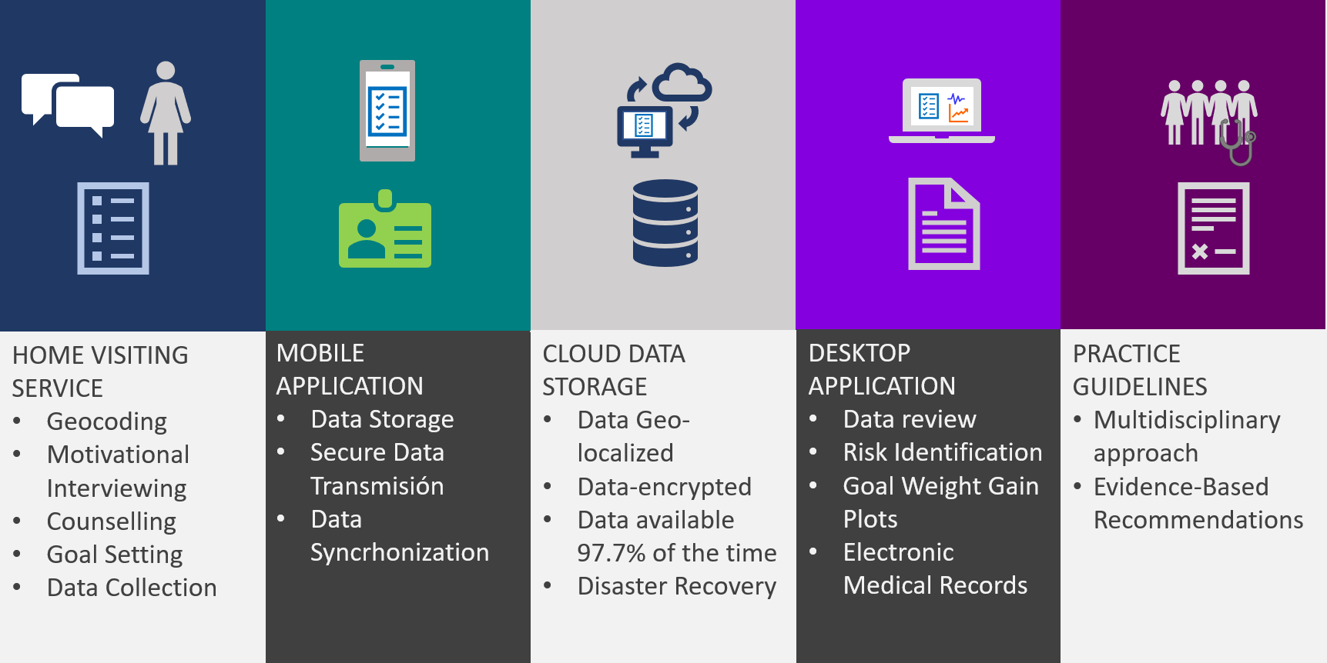
Figure 1. Components of the Home Visiting Service Framework Platform.
This figure portrays the main characteristics of the Home Visiting Service. The service consists of the: Home Visiting Service, mobile application, cloud data storage, desktop application, and practice guidelines.

Figure 2: Heartland Health Main Organization Chart
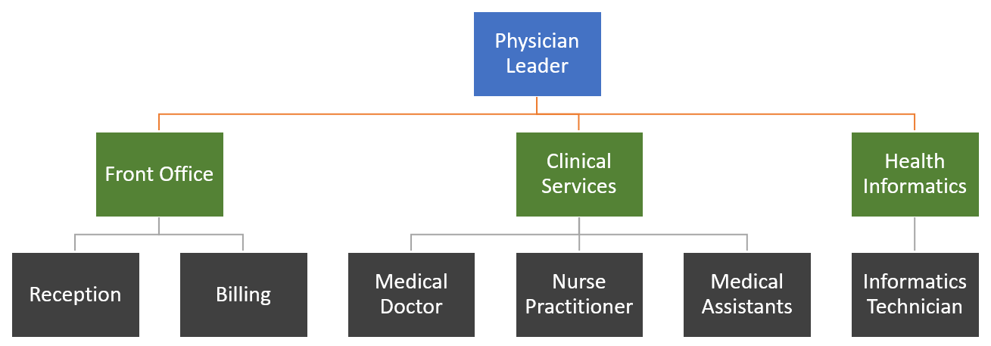
Figure 2. Heartland Health Main Organization Chart
This chart shows the different functional teams that integrate Heartland Health: Front Office, Clinical Services, and Health Informatics. Front Office team comprehends those services related to administrative activities. Clinical services are integrated by personnel in charge of delivering health care services within the organization. Finally, Health Informatics team includes those team members in charge of providing technical and technology services to the health care organization.

Figure 3: Heartland Health Leadership Organization Chart
Figure 3. Heartland Health Leadership Organization Chart
This chart is a graphical representation of the division of team members between the two locations. Each location has an identified team leader. Dashed lines enclose the different functional teams and their members. Arrows show the report line from managers to team members.

Figure 4. Heartland Health Proposed Strategic Plan
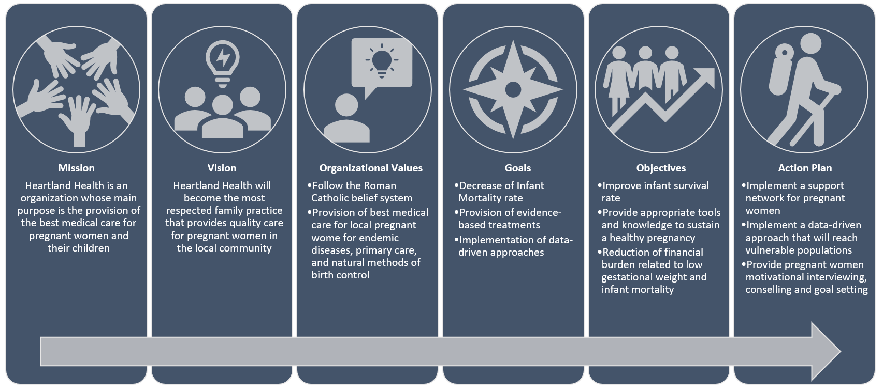
Figure 4. Heartland Health Proposed Strategic Plan
This image displays the strategic plan that will be proposed to Heartland Health. The main goal of this strategic plan is to transform Heartland Health into an organization that is known for providing the best medical care for pregnant women. The vision, organizational, values support this mission and the goals set the scope for action. As a result, we have three main action plans that can be achieved through the use of the Home Visiting Service and Framework.

Figure 5. Heartland Health SWOT Analysis
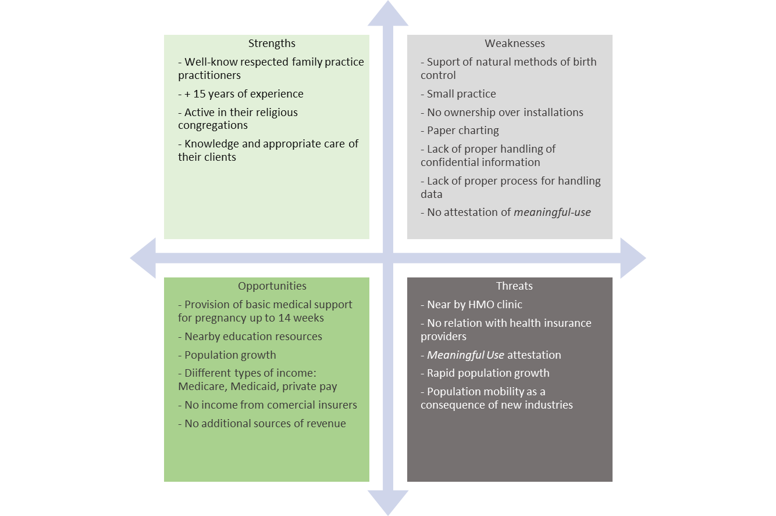
Figure 5. Heartland Health SWOT Analysis
This image shows the results of the SWOT Analysis for the Heartland Health organization. Strengths were defined by the current internal characteristics and practices that proved value. Opportunities were determined by identifying current external practices that can potentially provide the basis for future value. Weaknesses were identified as internal characteristics or processes that do not provide value to the organization and are a potential liability. Finally, Threats were identified as external factors than can cause a loss of value of the current practices or characteristics to the organization.

